Lab assignment 10.4
Task 1: Syntax and Error Detection
Wrong code:
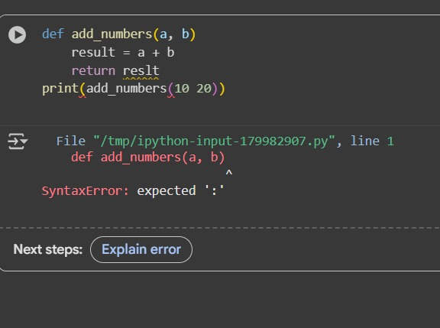
Correct code:
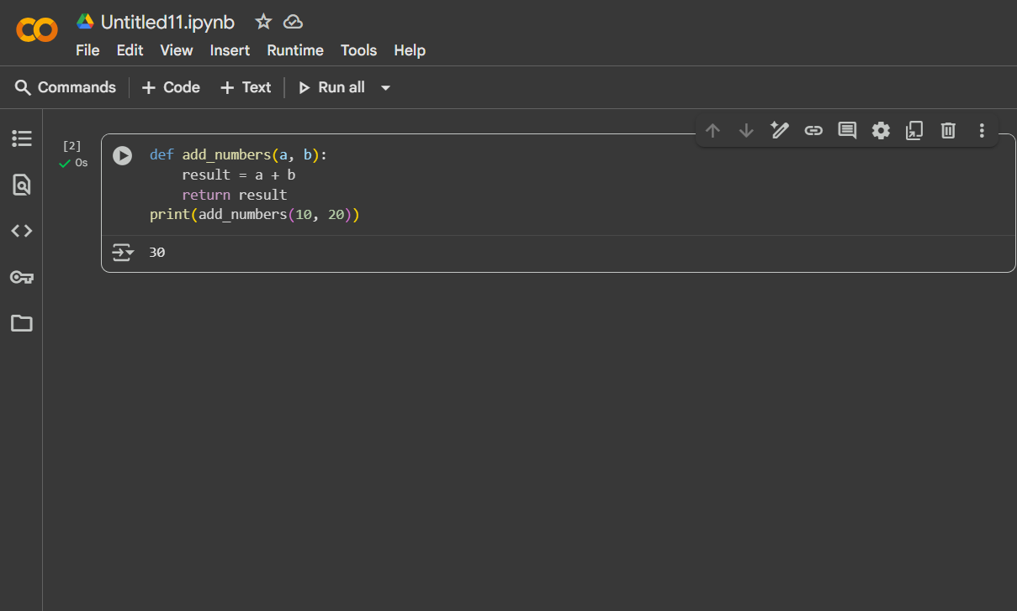
Task 2: Logical and Performance Issue Review
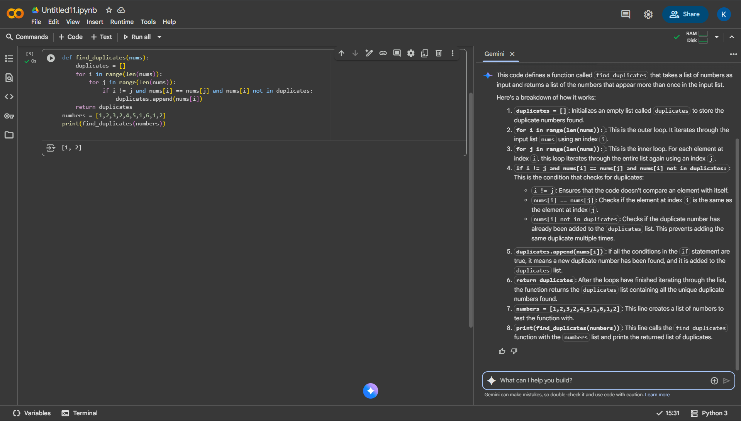
Optimized code:
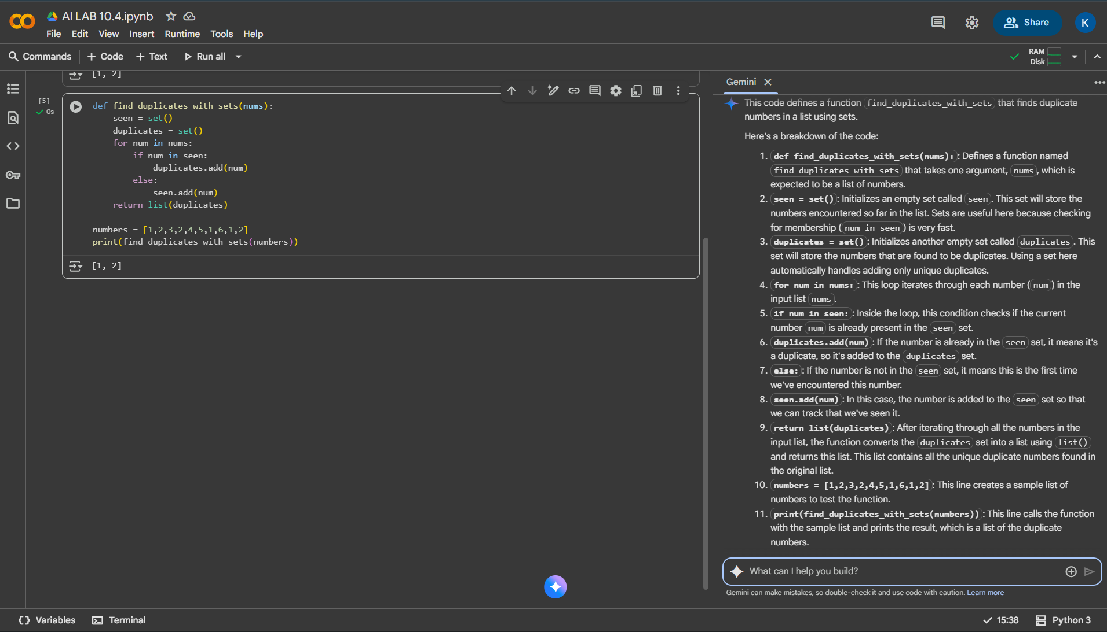

Task 3: Code Refactoring for Readability
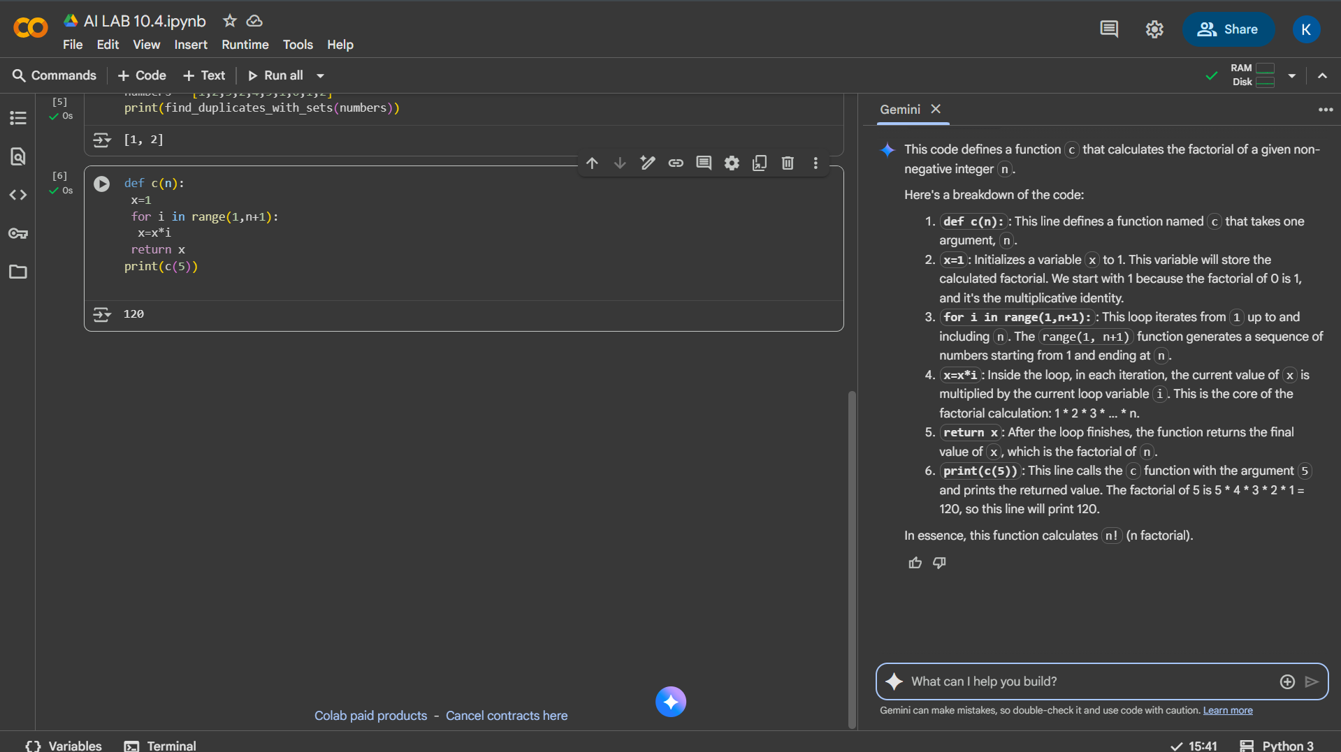
Function renamed to calculate_factorial:
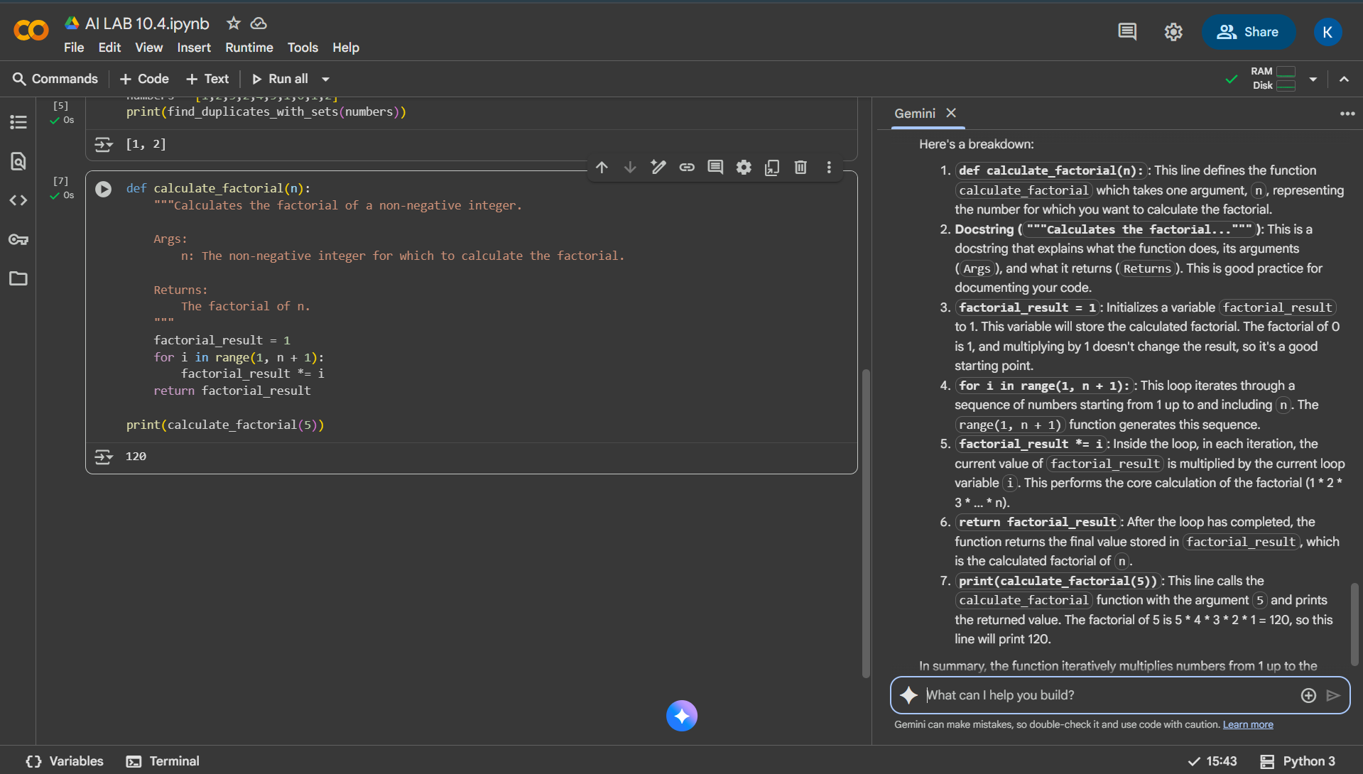

Task 4: Security and Error Handling Enhancement
Wrong code:
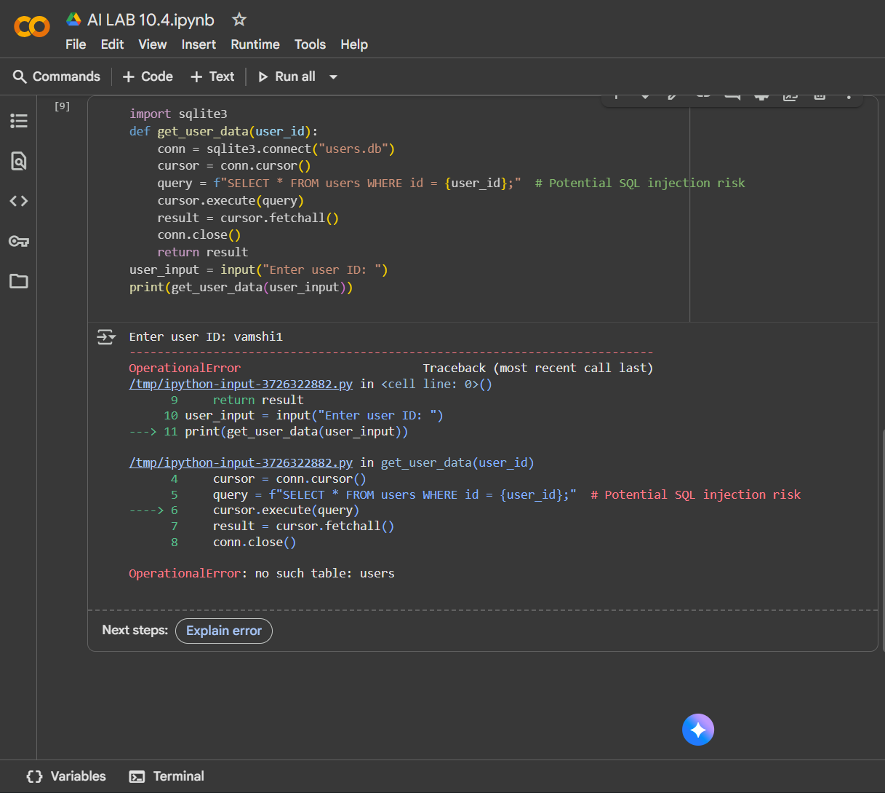
Correct code:
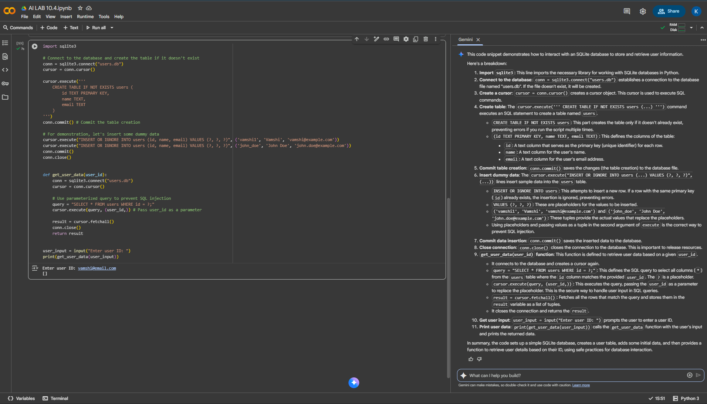
Task 5: Automated Code Review Report Generation
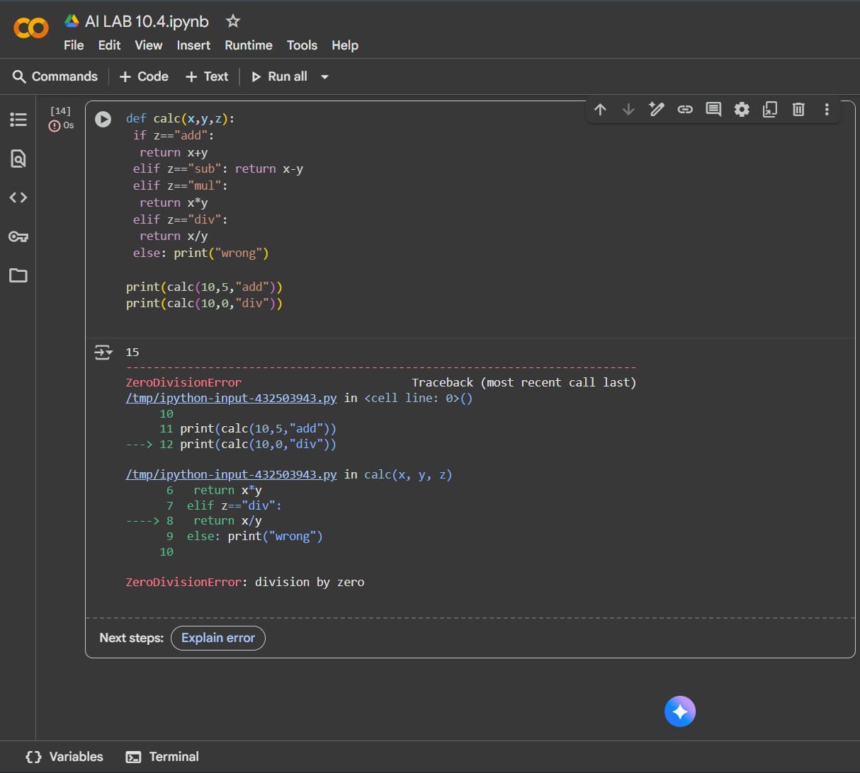
Correct code:
